Botrytis disease model report

Object

1. Evaluating the performance of botrytis model developed by González-Domínguez et al. (2015) (G-D Botrytis Model hereafter) under the growth conditions in Marlborough, New Zealand.
   1. Coupled the botrytis model with a phenology and growth stage model
   2. Calculate the severity index for the three different pathways by using the G-D Botrytis Model, and climatic and leaf wetness data in Marlborough at different sites
   3. Evaluate the correlation between the three-severity index and our field botrytis severity assessment, and try to find the physiological and pathological supports
   4. Evaluate whether the use of the severity index significantly improve the severity perdition compared to purely use leaf wetness and met data
   5. Improve the severity prediction through parameter optimization or more advanced statistical methods
2. Add the effects of treatments to the model for exploring different measures for reducing botrytis severity
3. Find out how model results relate to visual severity of botrytis disease, build a model of visual severity and results of G-D model, making it practical for growers, managers, and others.
4. Optimize and validate the model and predict botrytis disease severity, to help growers prevent and control the disease and reduce losses.
5. Improve the model, add the impact parameters of treatments, and explore the significance of the model for the application of control measures.
6. Try to figure out how visual severity relates to simulated severity and weather conditions, explain why botrytis disease is severe. It helps us understand disease occurrence and development and optimize prediction models.

Introduction

The mechanistic model developed by González-Domínguez et al. (2015) accounts for weather, vine growth stage, and the main infection pathways. The model considers two infection periods: the first period from "inflorescences clearly visible" to "berries groat-sized," and the second period from "majority of berries touching" to "berries ripe for harvest." During the first period, the model calculates the severity of infection on inflorescences and young clusters caused by conidia (SEV1). During the second period, the model calculates the severity of infection on ripening berries by conidia (SEV2) and the severity of berry-to-berry infection caused by mycelium (SEV3).

Outline

1. Introduce the grapevine growing, occurrence of botrytis and climate characteristics in Marlborough fitting (See Figure 1.). **(Partially done)**
2. The function of the model is realized by programming and applied in Marlborough New Zealand according to the description of G-D model in the article. **(Done)**
3. Use the growth stage simulated by APSIM instead of the real growth stage in the model, because the growth stage of each planting area is different, the data is not easy to obtain, and the APSIM simulation results are easy to obtain. Compare the real and simulated growth stage, the simulation results were acceptable (See Table 1, Phenology dates.xlsx from Rob, Project code: P/471008/01). **(Done)**
4. Fit and analyse the relationship between visual severity and SEV1, SEV2, SEV3 using linear, linear mixed, LOESS (LOcally WEighted Scatter-plot Smoother) curve fitting (See Table 2-4 and Figure 2-3). **(Done)**
   1. Evaluate whether the use of the severity index significantly improve the severity perdition compared to purely use leaf wetness and met data during the phase 2
5. Optimize and validate the model and predict botrytis disease severity. **(Partially done)**
6. Improve the model, add the impact parameters of treatments (See Table 5-6). Simulate the severity of botrytis disease under different treatments, the effect time lasts from January 1st to harvest date. Analyse the impact of different treatments on severity (See Figure 4, **this is a preliminary drawing, and the fitting relationship between SEV and severity has not been determined**.). **(Partially done)**
7. Optimize the calculation function for susceptibility in the model to align it better with the local actual situation. Optimize predictive model to obtain a range of severity. **(Just started)**
8. Try to figure out how visual severity relates to simulated severity and weather conditions during the infection windows, explain why botrytis disease is severe. **(Has not started)**

Figure 1. Daily rain and relative humidity time series plot (maybe just show 5 continus few years or get some summary information of the long-term climatic conditions from Rob)

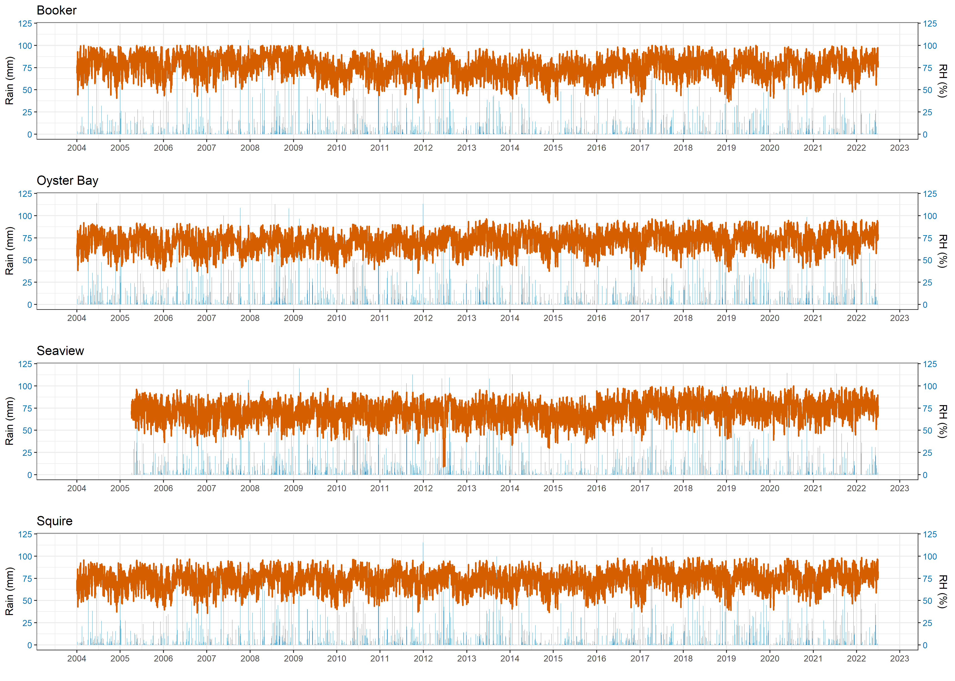

Table 1. Sauvignon Blanc phenology dates estimated by GDDs and simulated by APSIM in Marlborough

|  |  |  |  |  |  |  |  |  |
| --- | --- | --- | --- | --- | --- | --- | --- | --- |
|  | Oyster Bay | | Squire | | Booker | | Seaview | |
| Budburst | Phenology Dates | APSIM | Phenology Dates | APSIM | Phenology Dates | APSIM | Phenology Dates | APSIM |
| 2014-15 | 3/10/2014 | 6/10/2014 | 2/10/2014 | 4/10/2014 | 9/10/2014 | 7/10/2014 | 1/10/2014 | 2/10/2014 |
| 2015-16 | 10/10/2015 | 15/10/2015 | 4/10/2015 | 12/10/2015 | 10/10/2015 | 14/10/2015 | 5/10/2015 | 9/10/2015 |
| 2016-17 | 8/10/2016 | 9/10/2016 | 8/10/2016 | 5/10/2016 | 9/10/2016 | 9/10/2016 | 4/10/2016 | 4/10/2016 |
| 2017-18 | 9/10/2017 | 5/10/2017 | 5/10/2017 | 30/09/2017 | 6/10/2017 | 3/10/2017 | 1/10/2017 | 26/09/2017 |
| 2018-19 | 5/10/2018 | 4/10/2018 | 28/09/2018 | 30/09/2018 | 4/10/2018 | 3/10/2018 | 30/09/2018 | 30/09/2018 |
| 2019-20 | 10/10/2019 | 11/10/2019 | 30/09/2019 | 8/10/2019 | 10/10/2019 | 10/10/2019 | 30/09/2019 | 5/10/2019 |
| 2020-21 | 28/09/2020 | 30/09/2020 | 26/09/2020 | 25/09/2020 | 26/09/2020 | 28/09/2020 | 27/09/2020 | 23/09/2020 |
| 2021-22 | 5/10/2021 | 3/10/2021 | 1/10/2021 | 3/10/2021 | 6/10/2021 | 3/10/2021 | 4/10/2021 | 2/10/2021 |
| 2022-23 | 9/10/2022 |  | 29/09/2022 |  | 1/10/2022 |  | 30/09/2022 |  |
| Flowering |  |  |  |  |  |  |  |  |
| 2014-15 | 11/12/2014 | 9/12/2014 | 8/12/2014 | 6/12/2014 | 14/12/2014 | 10/12/2014 | 12/12/2014 | 13/12/2014 |
| 2015-16 | 8/12/2015 | 12/12/2015 | 6/12/2015 | 11/12/2015 | 8/12/2015 | 13/12/2015 | 12/12/2015 | 12/12/2015 |
| 2016-17 | 12/12/2016 | 9/12/2016 | 13/12/2016 | 9/12/2016 | 13/12/2016 | 13/12/2016 | 16/12/2016 | 13/12/2016 |
| 2017-18 | 5/12/2017 | 4/12/2017 | 4/12/2017 | 3/12/2017 | 7/12/2017 | 3/12/2017 | 8/12/2017 | 8/12/2017 |
| 2018-19 | 8/12/2018 | 5/12/2018 | 4/12/2018 | 3/12/2018 | 8/12/2018 | 5/12/2018 | 16/12/2018 | 12/12/2018 |
| 2019-20 | 7/12/2019 | 5/12/2019 | 2/12/2019 | 2/12/2019 | 5/12/2019 | 5/12/2019 | 7/12/2019 | 5/12/2019 |
| 2020-21 | 4/12/2020 | 4/12/2020 | 1/12/2020 | 1/12/2020 | 4/12/2020 | 3/12/2020 | 6/12/2020 | 3/12/2020 |
| 2021-22 | 6/12/2021 | 1/12/2021 | 1/12/2021 | 29/11/2021 | 7/12/2021 | 1/12/2021 | 7/12/2021 | 4/12/2021 |
| 2022-23 | 10/12/2022 |  | 5/12/2022 |  | 9/12/2022 |  | 9/12/2022 |  |
| 8 Brix |  | Veraison |  |  |  |  |  |  |
| 2014-15 | 9/02/2015 | 4/02/2015 | 6/02/2015 | 4/02/2015 | 7/02/2015 | 8/02/2015 | 13/02/2015 | 19/02/2015 |
| 2015-16 | 14/02/2016 | 13/02/2016 | 12/02/2016 | 12/02/2016 | 13/02/2016 | 14/02/2016 | 20/02/2016 | 20/02/2016 |
| 2016-17 | 18/02/2017 | 10/02/2017 | 13/02/2017 | 10/02/2017 | 19/02/2017 | 17/02/2017 | 21/02/2017 | 20/02/2017 |
| 2017-18 | 9/02/2018 | 26/01/2018 | 5/02/2018 | 24/01/2018 | 7/02/2018 | 25/01/2018 | 13/02/2018 | 4/02/2018 |
| 2018-19 | 8/02/2019 | 31/01/2019 | 4/02/2019 | 29/01/2019 | 6/02/2019 | 30/01/2019 | 15/02/2019 | 11/02/2019 |
| 2019-20 | 15/02/2020 | 7/02/2020 | 3/02/2020 | 6/02/2020 | 12/02/2020 | 8/02/2020 | 17/02/2020 | 17/02/2020 |
| 2020-21 | 6/02/2021 | 8/02/2021 | 1/02/2021 | 5/02/2021 | 4/02/2021 | 8/02/2021 | 5/02/2021 | 14/02/2021 |
| 2021-22 | 5/02/2022 | 29/01/2022 | 1/02/2022 | 26/01/2022 | 5/02/2022 | 27/01/2022 | 10/02/2022 | 5/02/2022 |
| 2022-23 |  |  |  |  |  |  |  |  |

Figure 2. Sauvignon Blanc severity in Marlborough

(Harvest 2005-2022 all data.xlsx from Rob)

Table 2. Linear curve fitting between visual severity and SEV1, SEV2, SEV3

|  |  |  |  |  |
| --- | --- | --- | --- | --- |
|  | Formula | R2 | LogLik | AIC |
| 1 | Severity ~ sev1 | 0.037256 | 67.61215 | -129.224 |
| 2 | Severity ~ sev2 | 0.115837 | 72.76354 | -139.527 |
| 3 | Severity ~ sev3 | 0.362755 | 92.57649 | -179.153 |
| 4 | Severity ~ sev1+sev2 | 0.139547 | 74.91858 | -141.837 |
| 5 | Severity ~ sev1+sev3 | 0.361945 | 93.01022 | -178.02 |
| 6 | Severity ~ sev2+sev3 | 0.368905 | 93.67378 | -179.348 |
| 7 | Severity ~ sev1+sev2+sev3 | 0.366961 | 94.00258 | -178.005 |

Table 3. Linear mixed curve fitting between visual severity and SEV1, SEV2, SEV3

|  |  |  |  |
| --- | --- | --- | --- |
|  | Formula | MSE | Adj_R_squared |
| 1 | Severity ~ sev1+(1|Site) | 0.015237 | 0.246657 |
| 2 | Severity ~ sev2+(1|Site) | 0.013205 | 0.347131 |
| 3 | Severity ~ sev3+(1|Site) | 0.009909 | 0.510057 |
| 4 | Severity ~ sev1 + sev2+(1|Site) | 0.012646 | 0.374762 |
| 5 | Severity ~ sev1 + sev3+(1|Site) | 0.009794 | 0.515761 |
| 6 | Severity ~ sev2 + sev3+(1|Site) | 0.009883 | 0.511387 |
| 7 | Severity ~ sev1 + sev2 + sev3+(1|Site) | 0.009778 | 0.51654 |

Table 4. LOESS curve fitting between visual severity and SEV1, SEV2, SEV3

|  |  |  |  |
| --- | --- | --- | --- |
|  | Formula | MSE | Adj_R_squared |
| 1 | Severity ~ sev1 | 0.01852 | 0.084327 |
| 2 | Severity ~ sev2 | 0.015743 | 0.221646 |
| 3 | Severity ~ sev3 | 0.011921 | 0.410604 |
| 4 | Severity ~ sev1 + sev2 | 0.014451 | 0.285518 |
| 5 | Severity ~ sev1 + sev3 | 0.009401 | 0.535193 |
| 6 | Severity ~ sev2 + sev3 | 0.009822 | 0.514369 |
| 7 | Severity ~ sev1 + sev2 + sev3 | 0.008928 | 0.558586 |

Figure 3. LOESS curve fitting between visual severity and SEV1, SEV2, SEV3

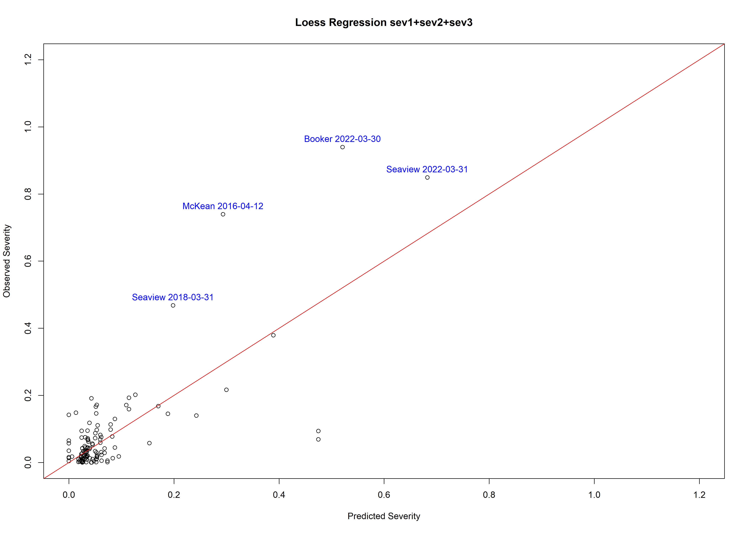

Table 5. Severity and incidence of Sauvignon Blanc with different treatments at Wither Hills

(Wither Hills Harvest Botrytis.xlsx from Stewart. Severity10 means larger than 10% botrytis severity.)

|  |  |  |  |  |  |  |
| --- | --- | --- | --- | --- | --- | --- |
| Treatment | Sampling Date | Year | Incidence 0.5 | Severity 0.5 | Incidence10 | Severity10 |
| Control | 22/03/2019 | 2019 | 23.75 | 0.50 | 0.00 | 0.00 |
| Control | 18/03/2020 | 2020 | 7.00 | 1.68 | 4.50 | 0.15 |
| Control | 19/03/2021 | 2021 | 15.09 | 0.59 | 0.81 | 0.12 |
| Control | 18/03/2022 | 2022 | 32.2 | 9.542 | 23.6 | 0.36 |
| Control | 29/03/2023 | 2023 | 37.2 | 5.197 | 10.8 | 0.38 |
| Shake | 22/03/2019 | 2019 | 13.75 | 0.78 | 2.50 | 0.00 |
| Shake | 18/03/2020 | 2020 | 1.50 | 0.13 | 0.50 | 0.05 |
| Shake | 19/03/2021 | 2021 | 11.68 | 0.19 | 0.00 | 0.02 |
| Shake | 18/03/2022 | 2022 | 21.7 | 5.784 | 13.6 | 0.26 |
| Shake | 29/03/2023 | 2023 | 29.4 | 2.412 | 4 | 0.38 |
| Collard | 22/03/2019 | 2019 | 13.75 | 0.19 | 0.00 | 0.00 |
| Collard | 18/03/2020 | 2020 | 2.00 | 0.22 | 0.50 | 0.05 |
| Collard | 19/03/2021 | 2021 | 10.43 | 0.15 | 0.00 | 0.00 |
| Collard | 18/03/2022 | 2022 | 21.00 | 4.22 | 10.60 | 0.25 |
| Collard | 29/03/2023 | 2023 | 32.20 | 1.63 | 2.10 | 0.31 |
| Collard & shake | 22/03/2019 | 2019 | 2.50 | 0.03 | 0.00 | 0.00 |
| Collard & shake | 18/03/2020 | 2020 | 2.50 | 0.51 | 1.50 | 0.00 |
| Collard & shake | 19/03/2021 | 2021 | 8.77 | 0.14 | 0.00 | 0.00 |
| Collard & shake | 18/03/2022 | 2022 | 10.70 | 1.31 | 3.40 | 0.20 |
| Collard & shake | 29/03/2023 | 2023 | 24.40 | 0.67 | 0.60 | 0.09 |

Table 6. Factors affecting the severity of Sauvignon Blanc

| Treatment | Factor |
| --- | --- |
| Control | 1.0 |
| Mechanical shake | 0.52 |
| Collard | 0.37 |
| Mechanical shake & Collard | 0.15 |

Figure 4. Model output at Wither Hills

Predicted relative infection severity (RIS) on inflorescences and young clusters by conidia (RIS1; blue bars) during the first infection period, and on ripening berries by conidia (RIS2; green bars) and mycelium (berry-to-berry infection) (RIS3; orange bars) during the second infection period.

Lines indicate the accumulated values of RIS1 (SEV1; red line) and of RIS2+RIS3 (SEV2+SEV3; red line); bule, green, orange lines mean the accumulated values of RIS1 and of RIS2+RIS3 with mechanical shake, collard, and both shake & collard treatments.

